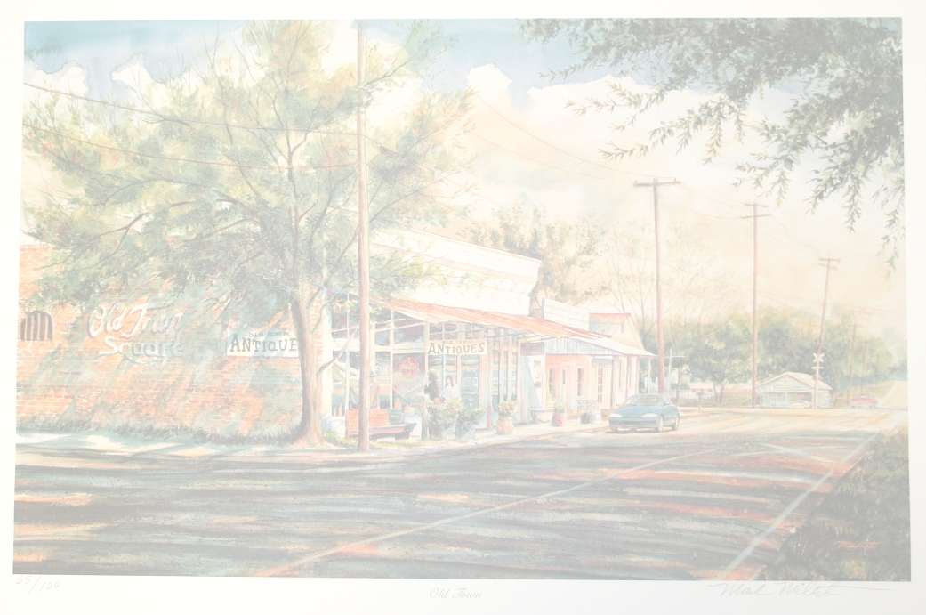
The Mayor and Board of Aldermen
of the City of Ridgeland
and the Historical Society of Ridgeland
cordially invite you to attend the
Unveiling
of the
Ridgeland Historical Marker

Tuesday, the seventeenth of June
Two thousand and fourteen
at eleven o’clock in the morning

Olde Towne Ridgeland Plaza
Corner of West Jackson Street and Northeast Madison Drive
Ridgeland, Mississippi

Exhibits may be viewed immediately following the event and include the
Ridgeland Town Charter, historical maps, and historical photos.

In case of inclement weather, the event will be held at the following location:
Fellowship Hall, First United Methodist Church of Ridgeland, 234 W. Jackson Street
Old Town
Mark Millet

